Week 1 Lab Task
Hamna Sarfraz
Lab Setup & Information Gathering
NIAI NAVTTC — Certified Ethical Hacker (CEH) Course
⚠ Important: All tasks must be performed only in your isolated virtual lab environment. Never test on real networks or systems without explicit written permission.

Task: Hands-on practice on setting up your cybersecurity lab environment and performing basic information gathering.

▶ Practice Basic Linux Commands
ls # List files in current directory
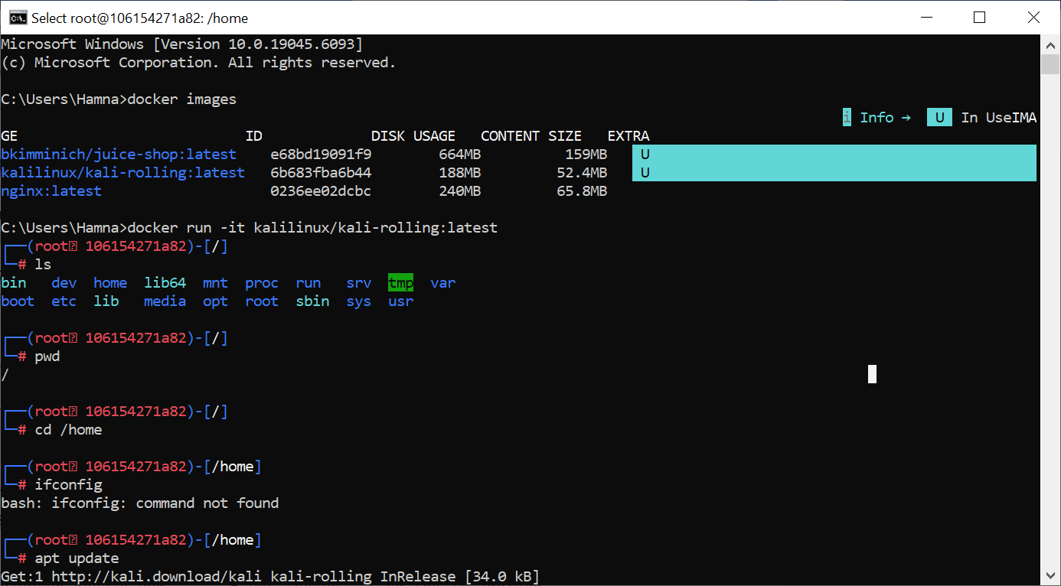
pwd # Print current working directory

cd /home # Change directory

ifconfig # Show network interfaces and IP addresses
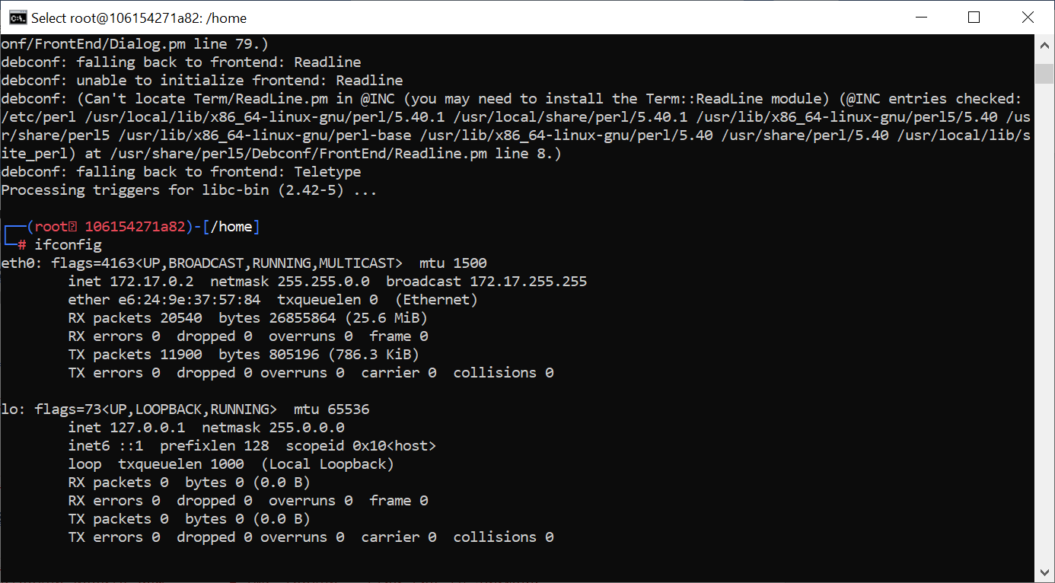
ping google.com # Test network connectivity
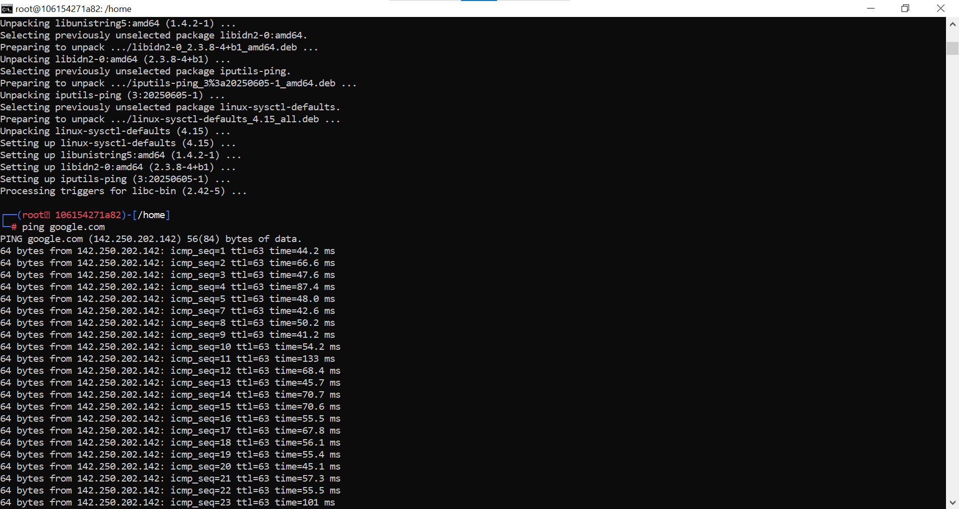
whoami # Show current logged-in user
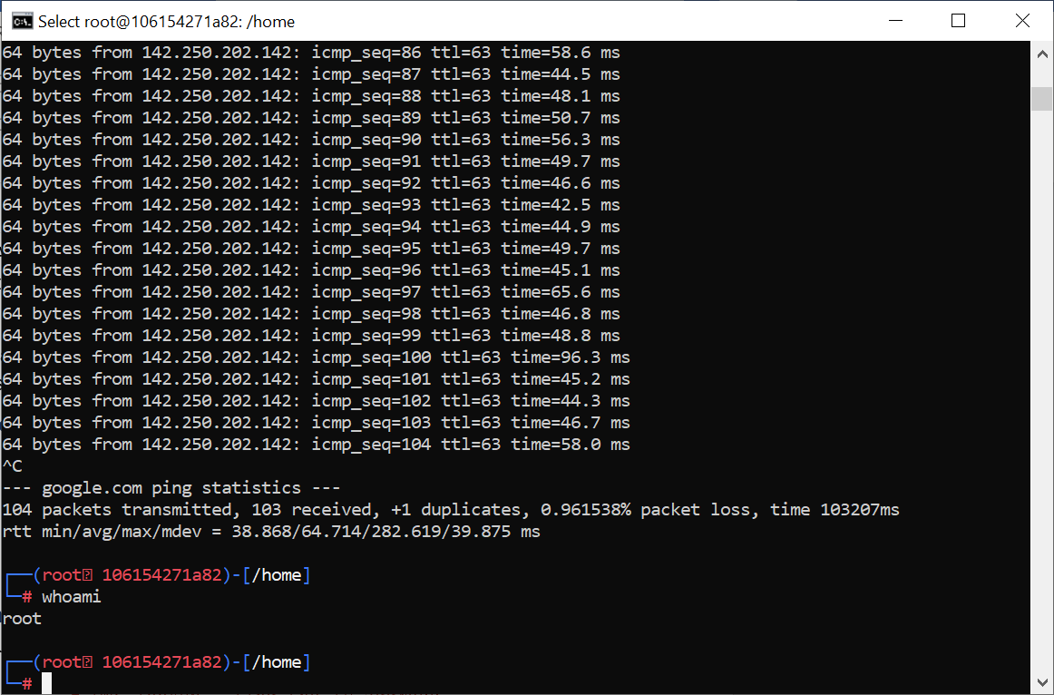
▶ Basic Information Gathering
Open a terminal in Kali and run the following:
whois google.com # See domain registration details
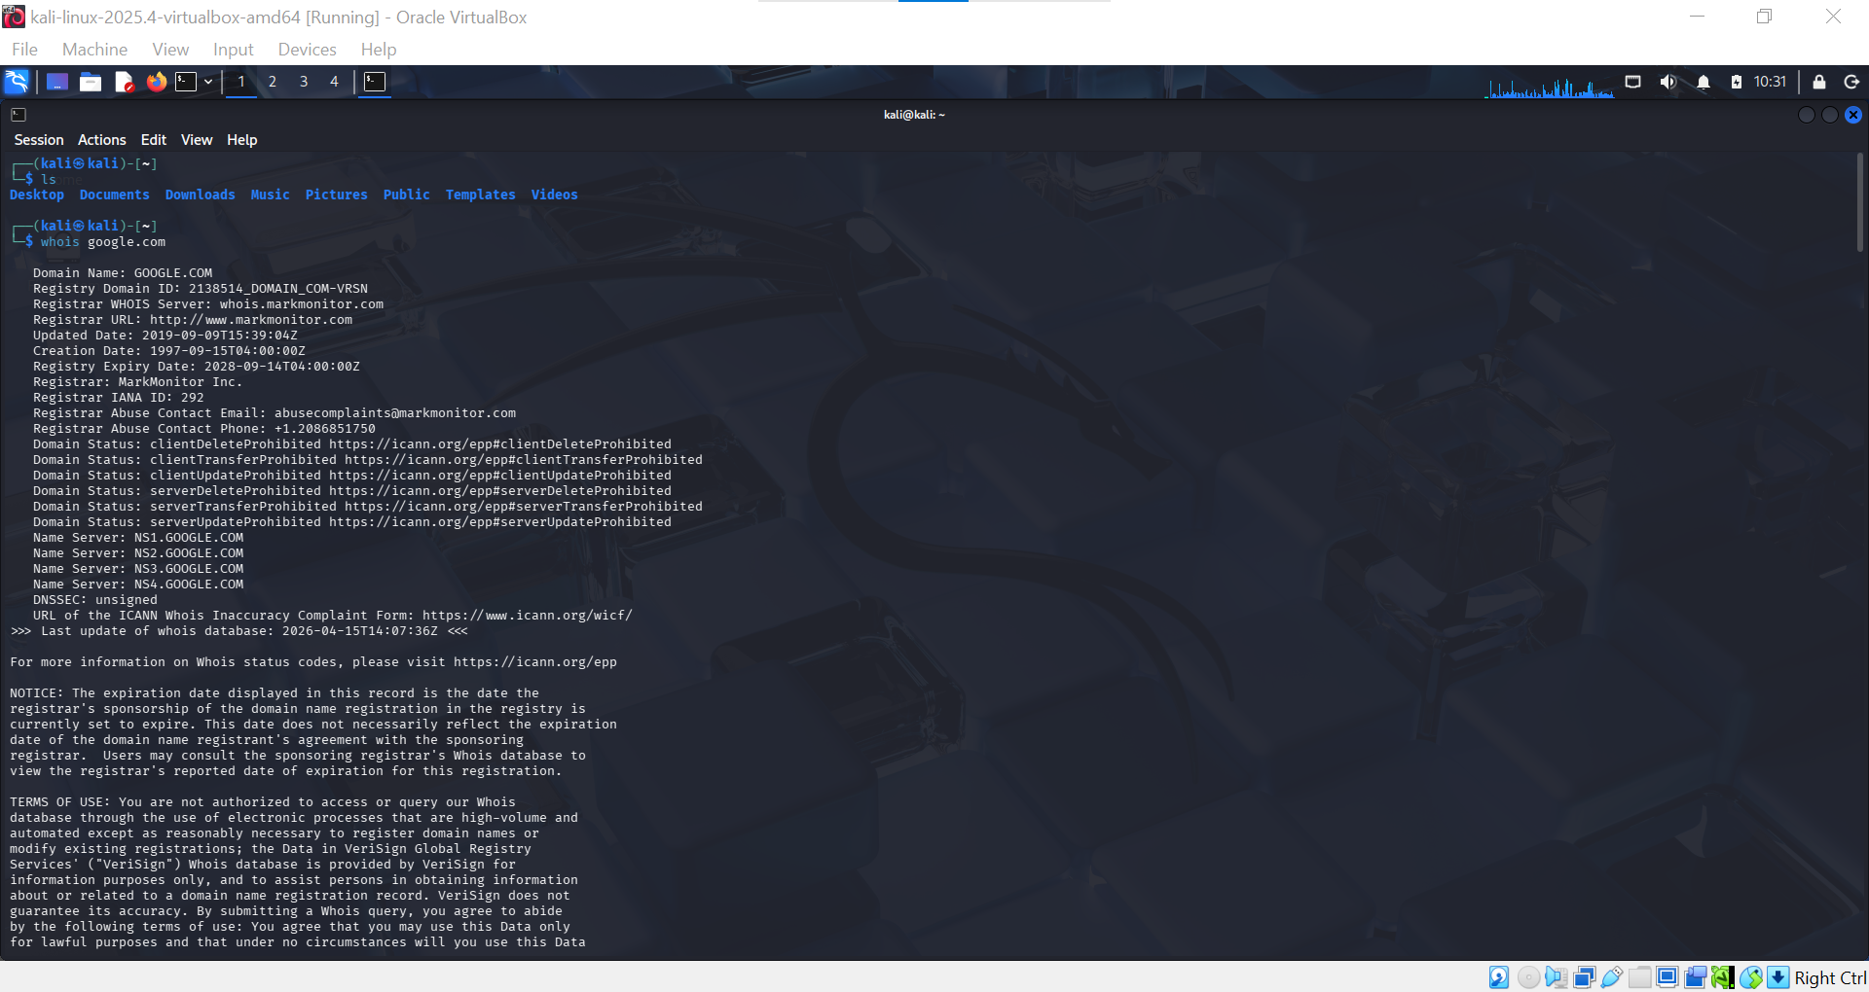
nslookup google.com # DNS lookup — find the IP address
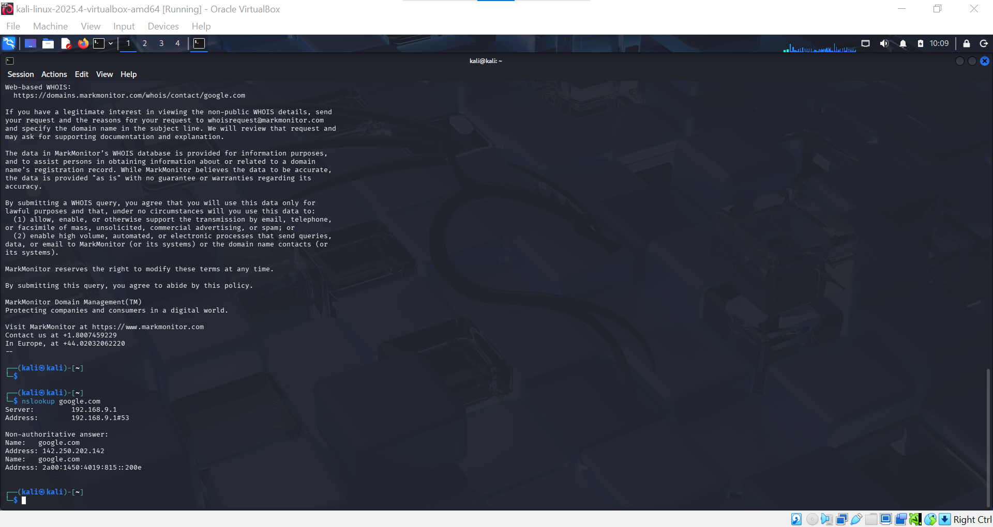
ping google.com # Basic connectivity check
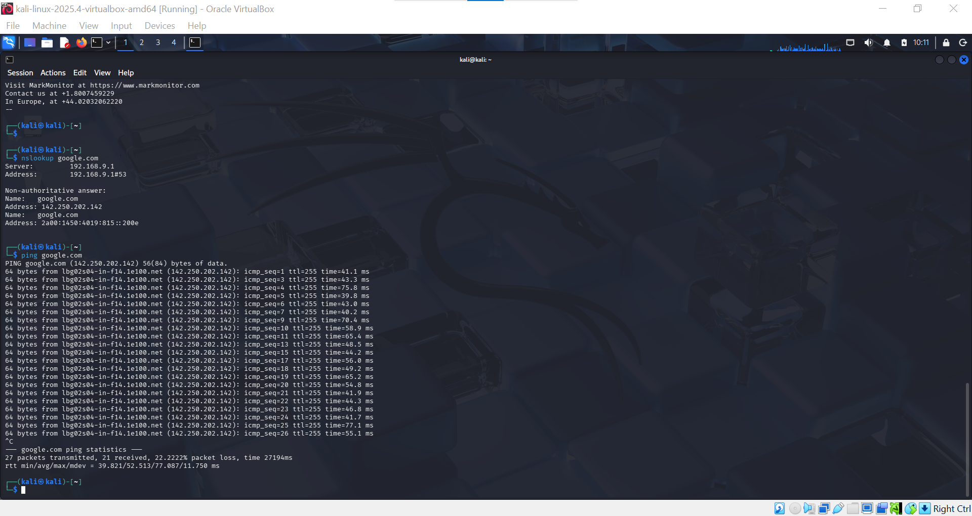

🎯 Goal: Your lab environment is fully set up, Kali Linux is running, and you can execute basic Linux and information-gathering commands successfully.

